Exploratory Data Analysis for Covid-19

Data Science Capstone Project
Data Acquisition and Preprocessing Report
10/26/2020

Team Members:
Avani Jain
Toby Sheung
Michael Wesner

Identifying Data

Data Sources:
Below is the COVID-19 dataset that is collected for every country from December 2019 to the date in which a user downloads the dataset. It contains every date from those ranges and details the total cases, new cases, total deaths, new deaths for each country. This dataset is quite extensive and contains more than 49,000 rows and 41 columns detailing numbers of COVID-19. We chose this dataset due to its extensive information and how the numbers are stated for each day.
- https://covid.ourworldindata.org/

Below is our second dataset that we used to detail the sex and age groups of COVID-19 related deaths in the United States. Since the first dataset did not have information about age groups and sex, this dataset will be combined into our project to explain how COVID-19 affects age groups and/or sex differently. This will help to further explore the trends of COVID-19 deaths.
- https://data.cdc.gov/NCHS/Provisional-COVID-19-Death-Counts-by-Sex-Age-and-S/9bhg-hcku

The third dataset contains COVID-19 information on total cases and deaths by sex for each country. The dataset reports the date when the case and death count was reported. It shows the proportion of cases and death for males and females.
- https://globalhealth5050.org/the-sex-gender-and-covid-19-project/dataset/

Acquisition Process:
There are currently three datasets we are using for this project. All datasets are ready for download in either a CSV or XLSX data file. All are downloadable from their respective websites. The datasets are acquired from public sources. We will not integrate any of datasets together because age groups and sex US dataset cannot be integrated into the other datasets about countries’ COVID-19 cases and deaths. Each dataset will be analyzed separately to understand the trends of COVID-19.

Data Processing

The first countries dataset requires an extensive amount of data processing due to its missing values.
- There are some countries missing dates in the dataset.
  - We decided to remove the countries that are missing dates in the dataset.

- There are multiple columns in the countries dataset that are extrapolated from other columns.
  - We decided to remove columns that are 7 day smoothed averages.

- There are multiple columns that had NA values in the first dates of the dataset.
  - We made the first date equal to zero in the columns that had NA values and front filled them with zero.

The case and death by gender countries dataset did not need much data processing.
- There are a few countries that did not have any data reported.
  - We decided to drop those countries that did not report any data.

Appendix
- COVID-19 Dataset with Countries: https://covid.ourworldindata.org/
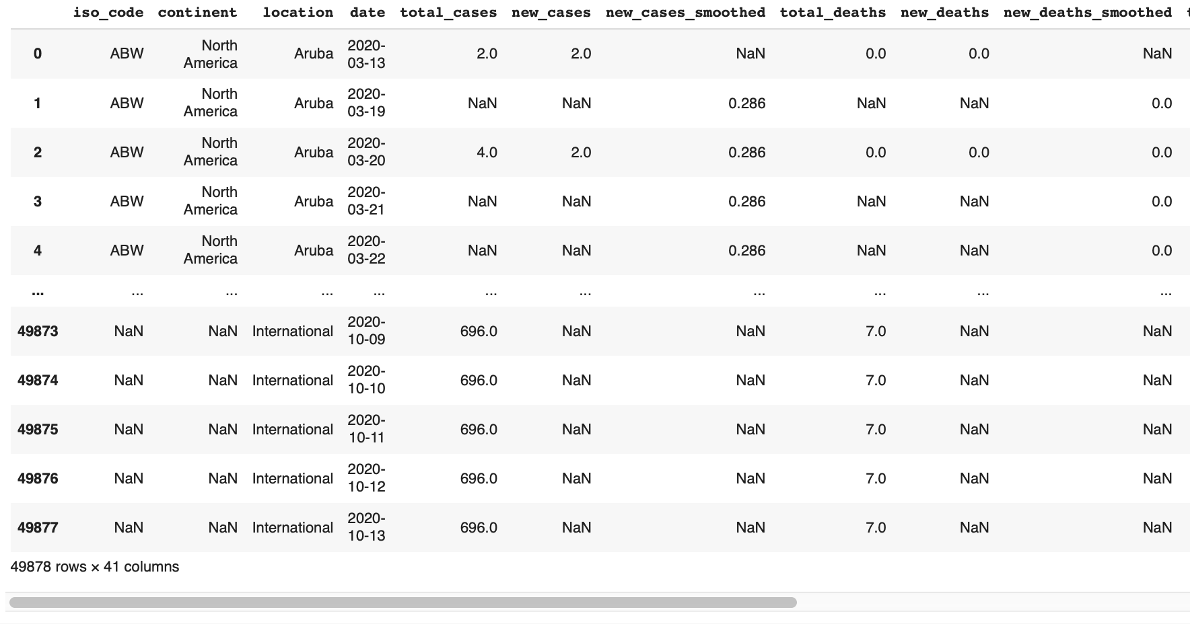
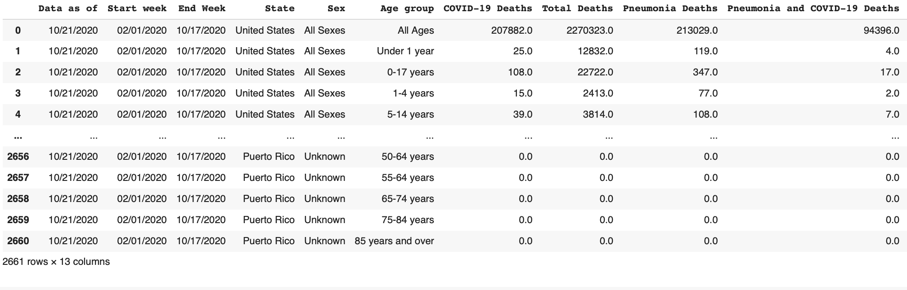
- COVID-19 Dataset with Gender and Age: https://data.cdc.gov/NCHS/Provisional-COVID-19-Death-Counts-by-Sex-Age-and-S/9bhg-hcku
- COVID-19 Dataset by Country and Gender:
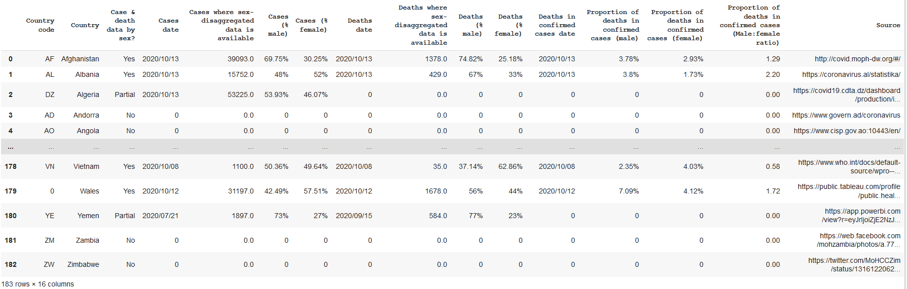
https://globalhealth5050.org/the-sex-gender-and-covid-19-project/dataset/

Table of Contributions
The table below identifies contributors to various sections of this document.

 | Section | Writing | Editing
1 | Data Sources | Toby, Michael | Michael
2 | Data Pre-Processing | Toby, Michael | Michael
3 | Appendix | Toby, Michael

